Topic 6 :

Lesson 1:

What is **Loop** in programming language ?

In computer programming, a loop is a sequence of [instruction](https://www.techtarget.com/whatis/definition/instruction)s that is continually repeated until a certain condition is reached.

If you want show a message 5o times ,then rather than typing the same code 50 times ,you can use loops .

* There are three types of loops in java :
* for loop
* while loop
* do while loop

**Lesson 2** :

for loop - When you know exactly how many times you want to loop through a block of code, use the for loop

how to write for loop in java-:

for ( initial expression ,test condition , update expression )

{

// your code here

}

1. **initial expression** : The initial expression initializes and/or declares variables and executes only once.
2. **test condition** : It is used for testing the exit condition for a loop.

If the condition is true , the body of the for loop is executed

1. **update expression** : update expression update the value of initial expression .

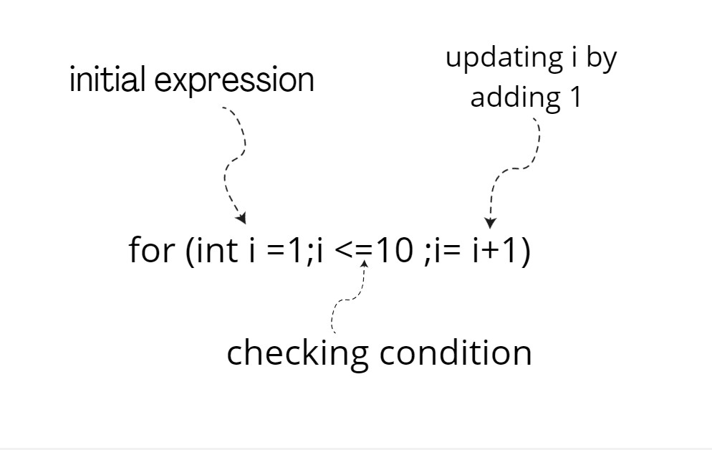

Example :

Display a text “ java is easy ”

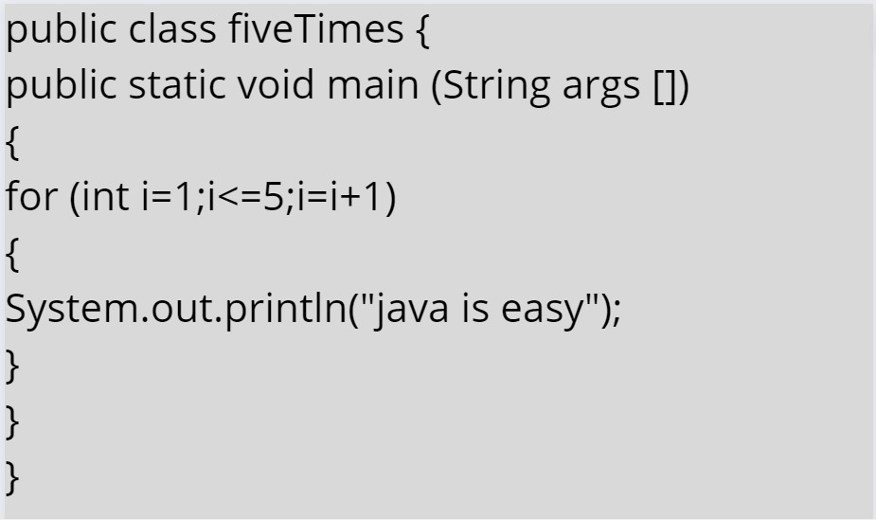

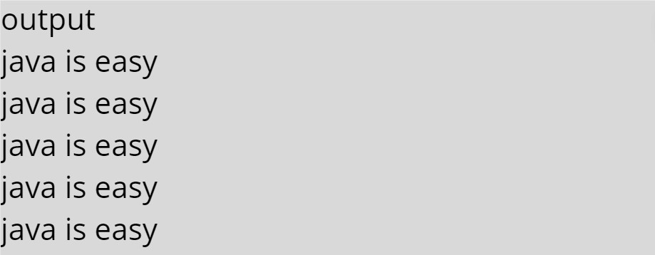

**Lesson 3 :**

While loop - while loop is used to iterate a part of the [program](https://www.javatpoint.com/programs-list) repeatedly until the specified Boolean condition is true. As soon as the Boolean condition becomes false, the loop automatically stops.

While(condition / expression )

{

//code to be executed

// update expression

}

Example

Print “java is fun” 5 times

Code

output

Int i=1;

while(i<=5)

{

System.out.println(“java is fun “);

i=i+1;

}

While(int i<=5)

java is fun

java is fun

java is fun

java is fun

java is fun